Digital Lab 4:

Experiment 6:

EEPROM

Date: 2024/05/07

Class: 電機三全英班

Group: Group 11

Name: B103105006 胡庭翊

1. Annotated Code

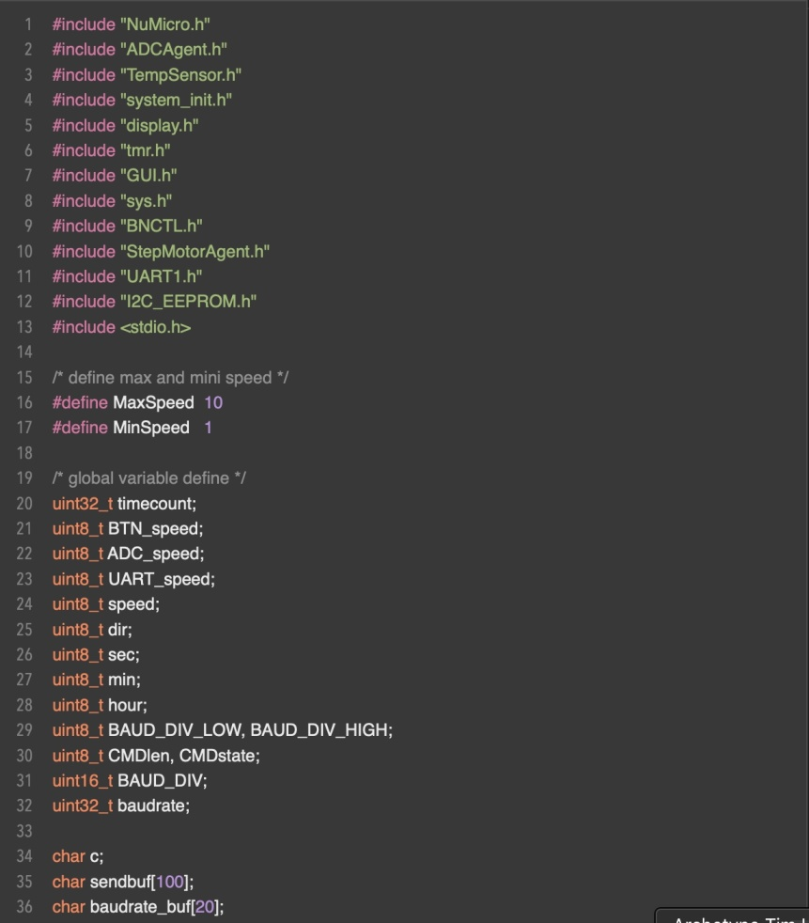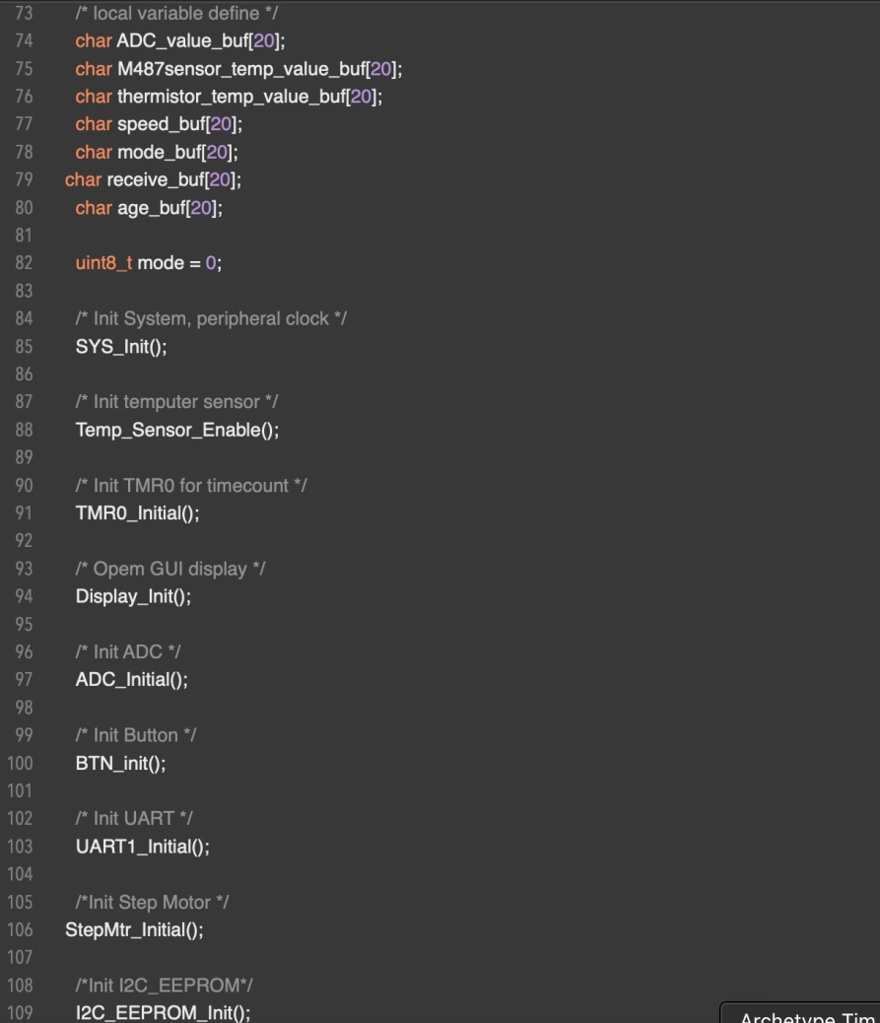

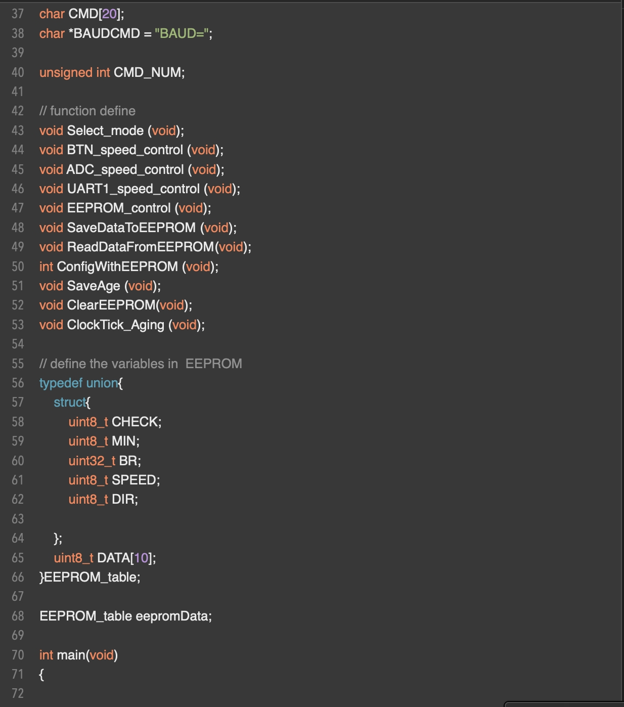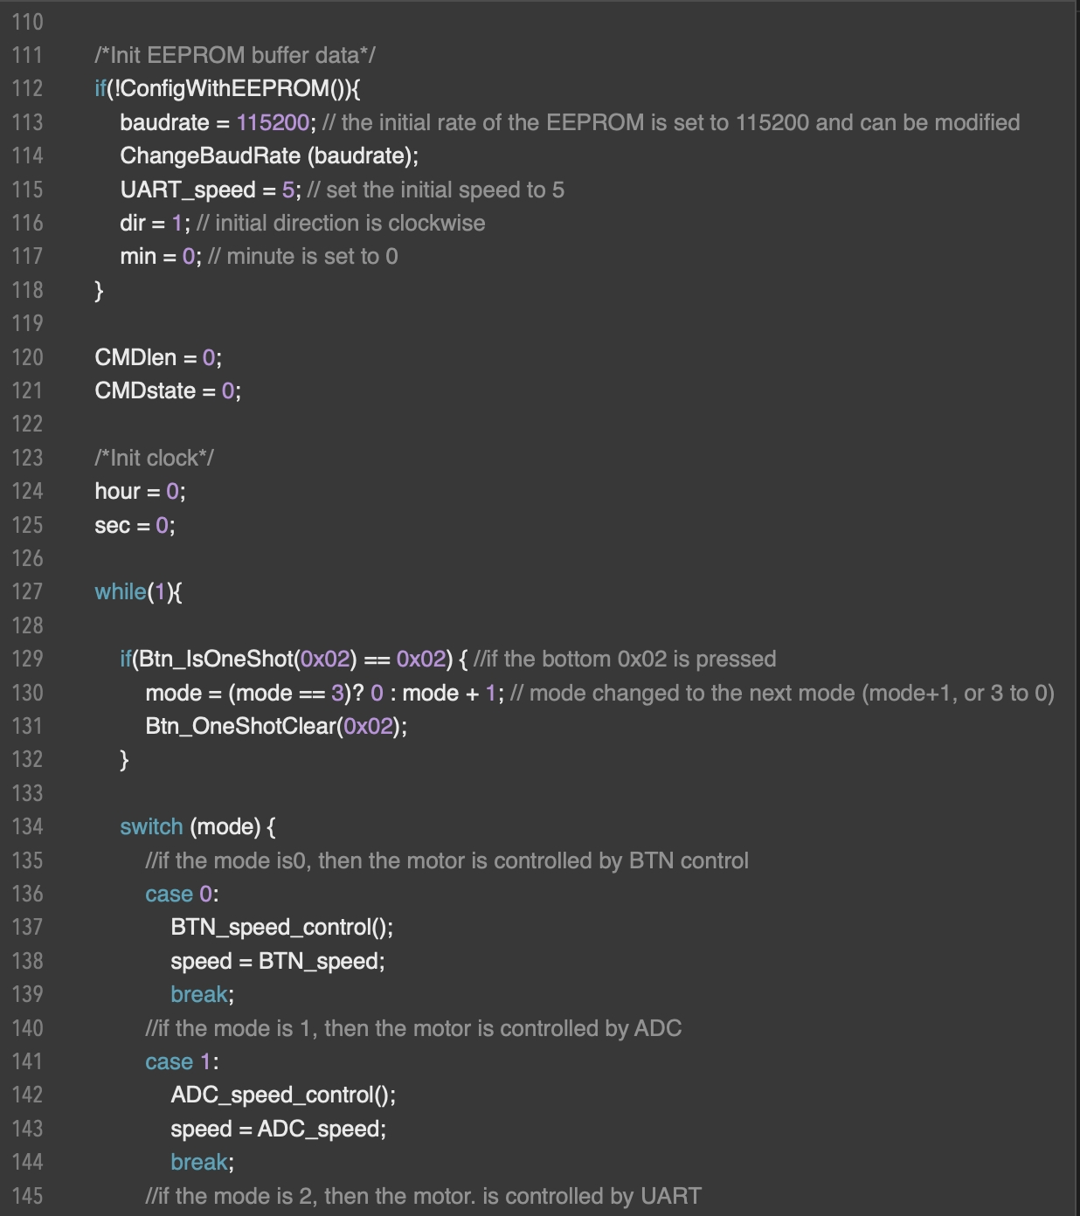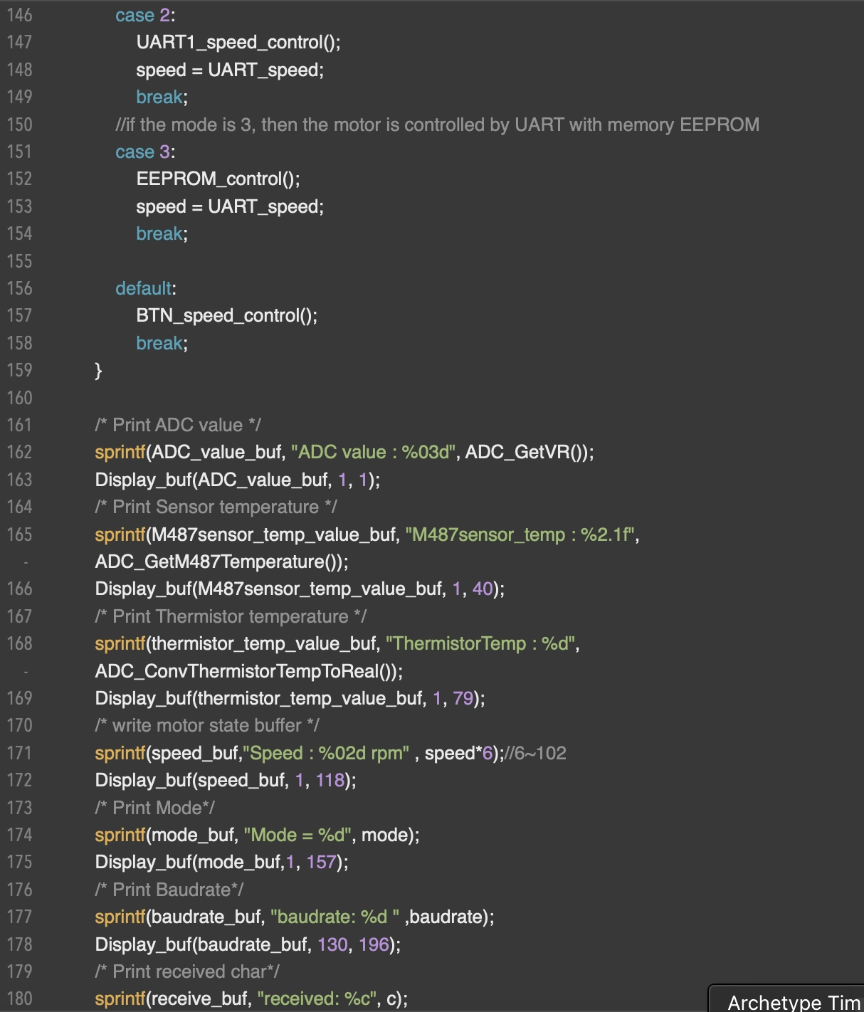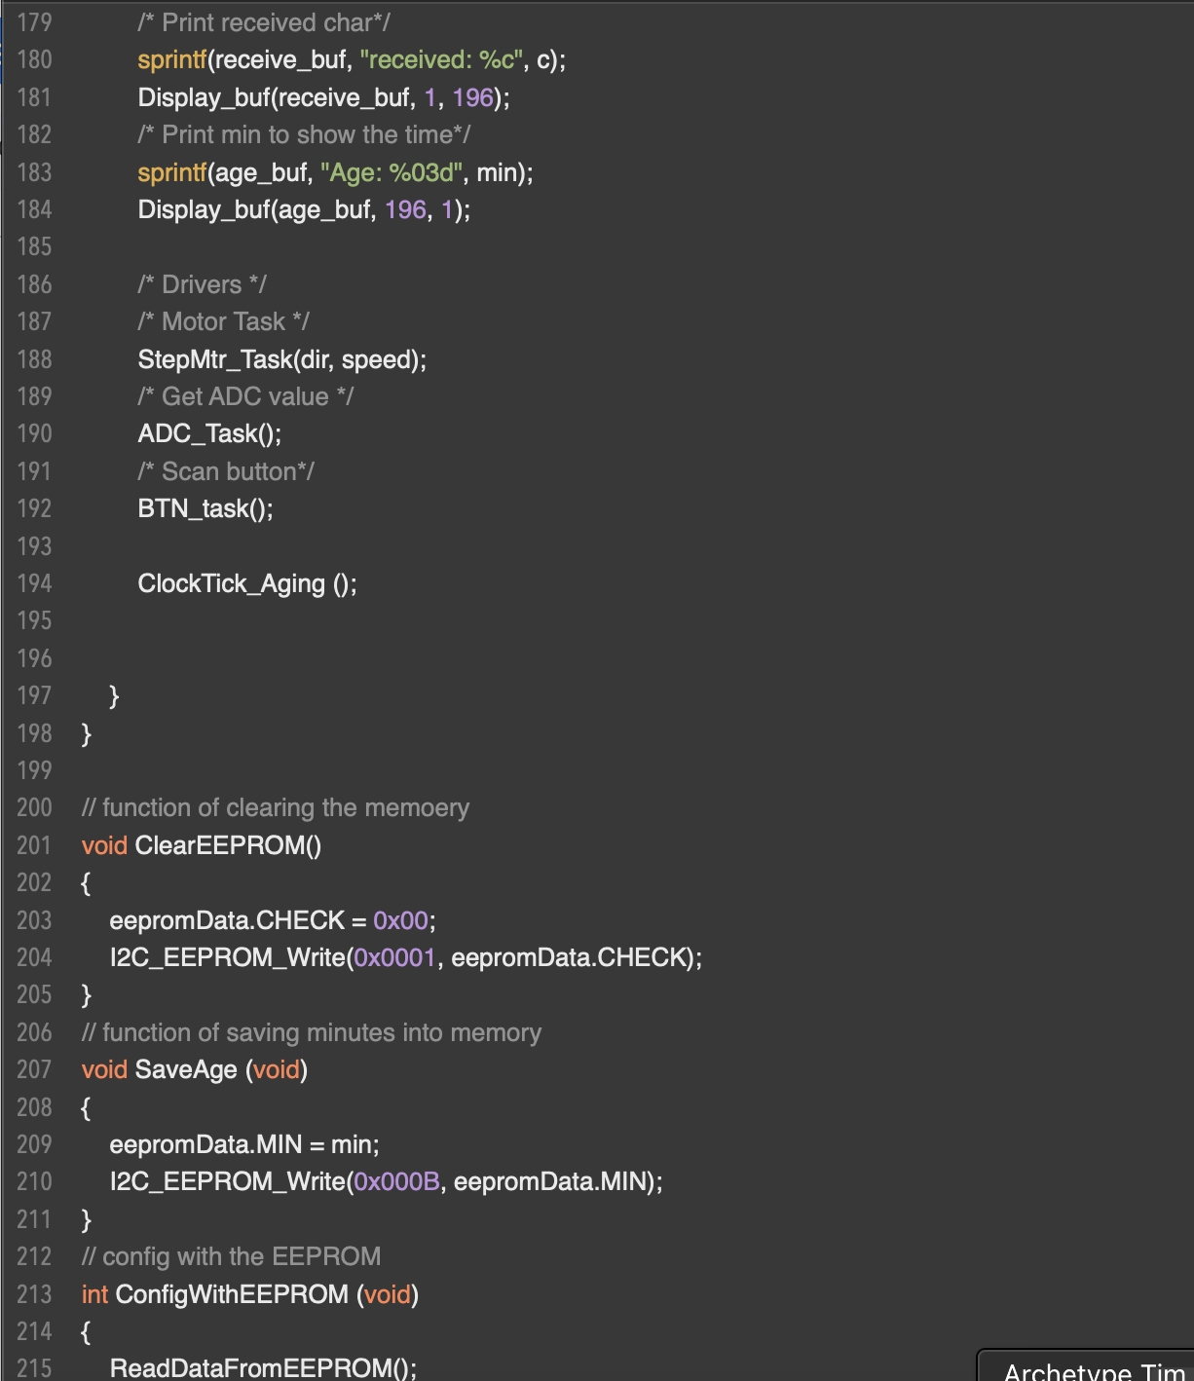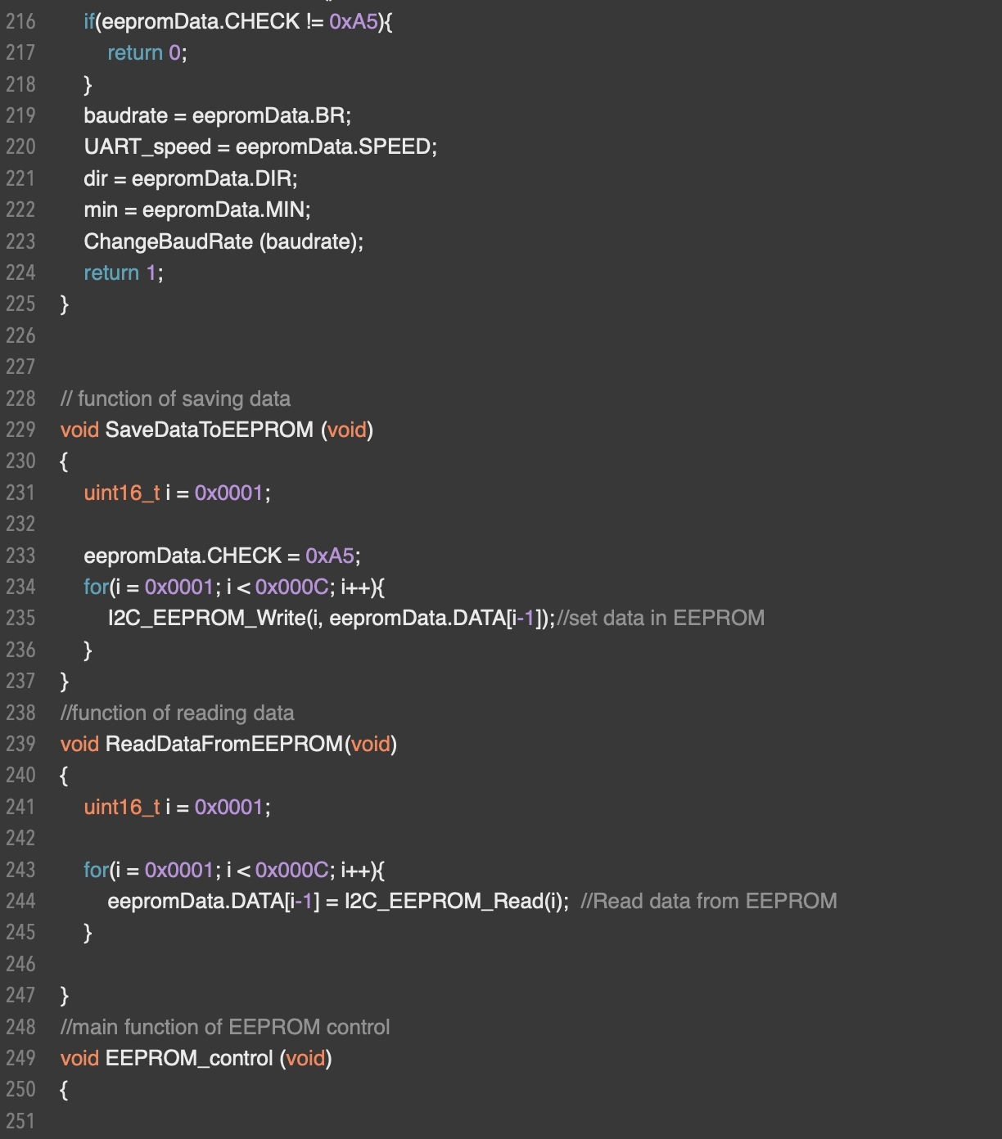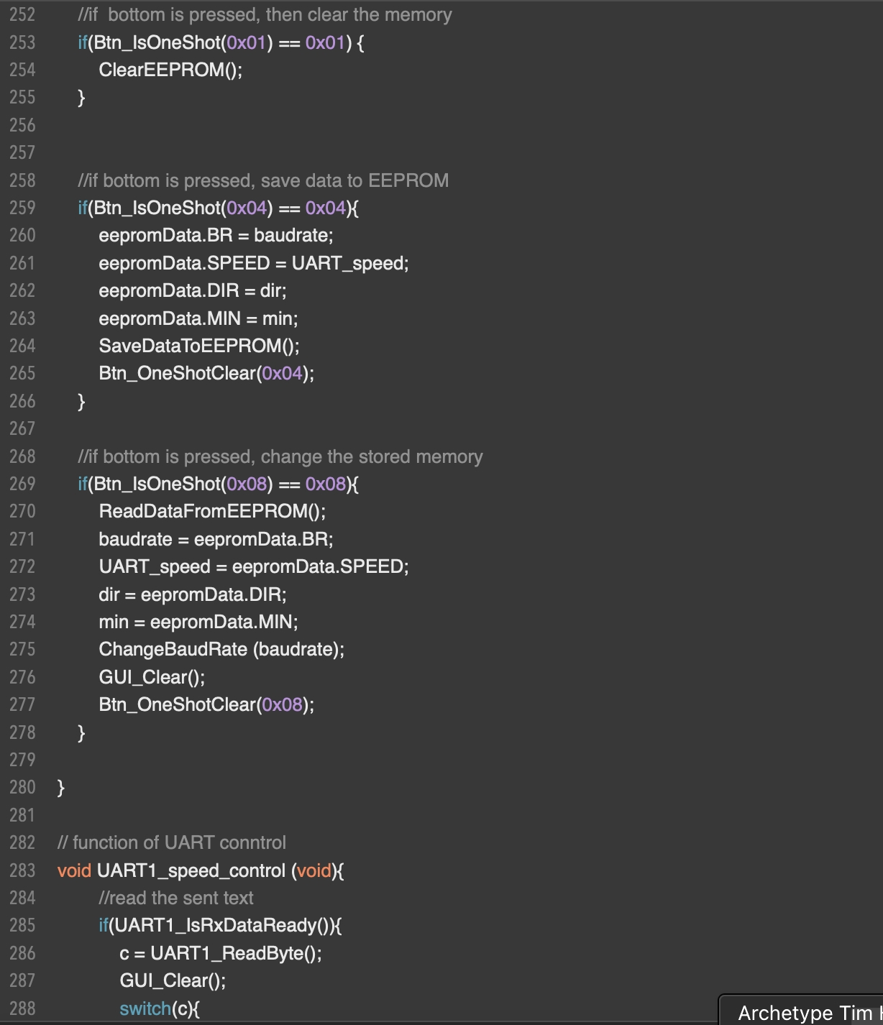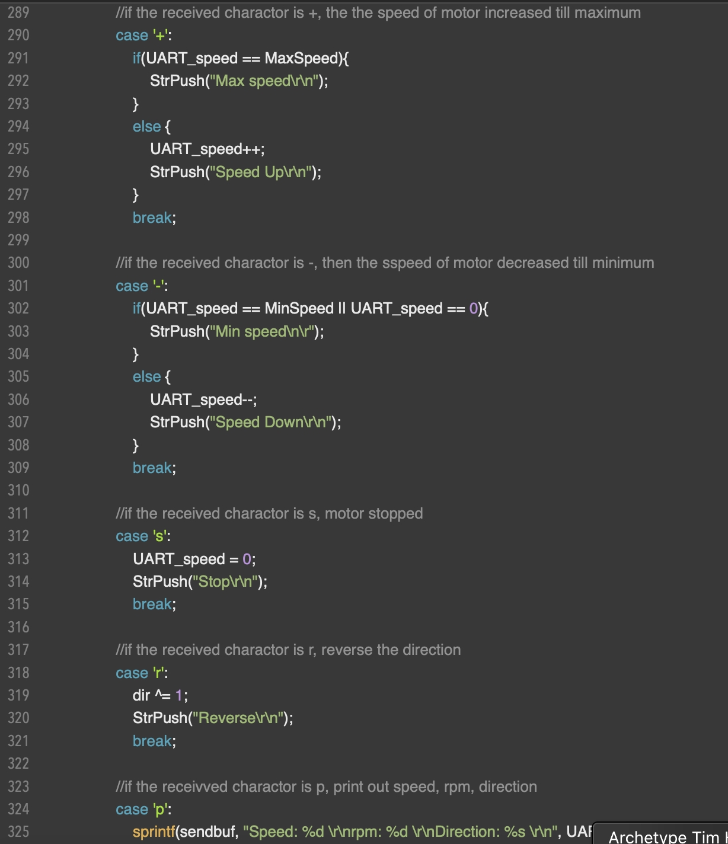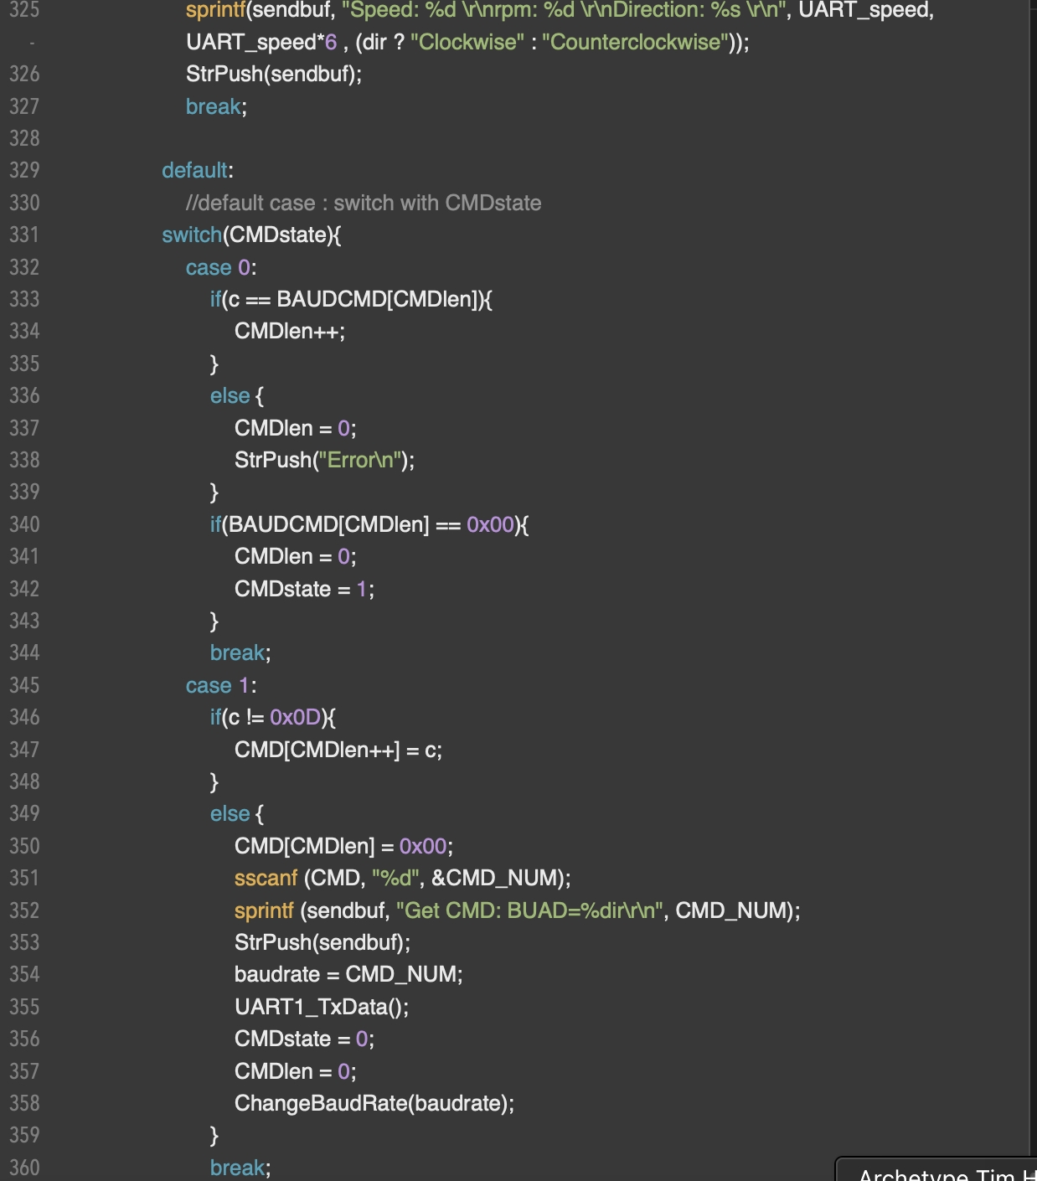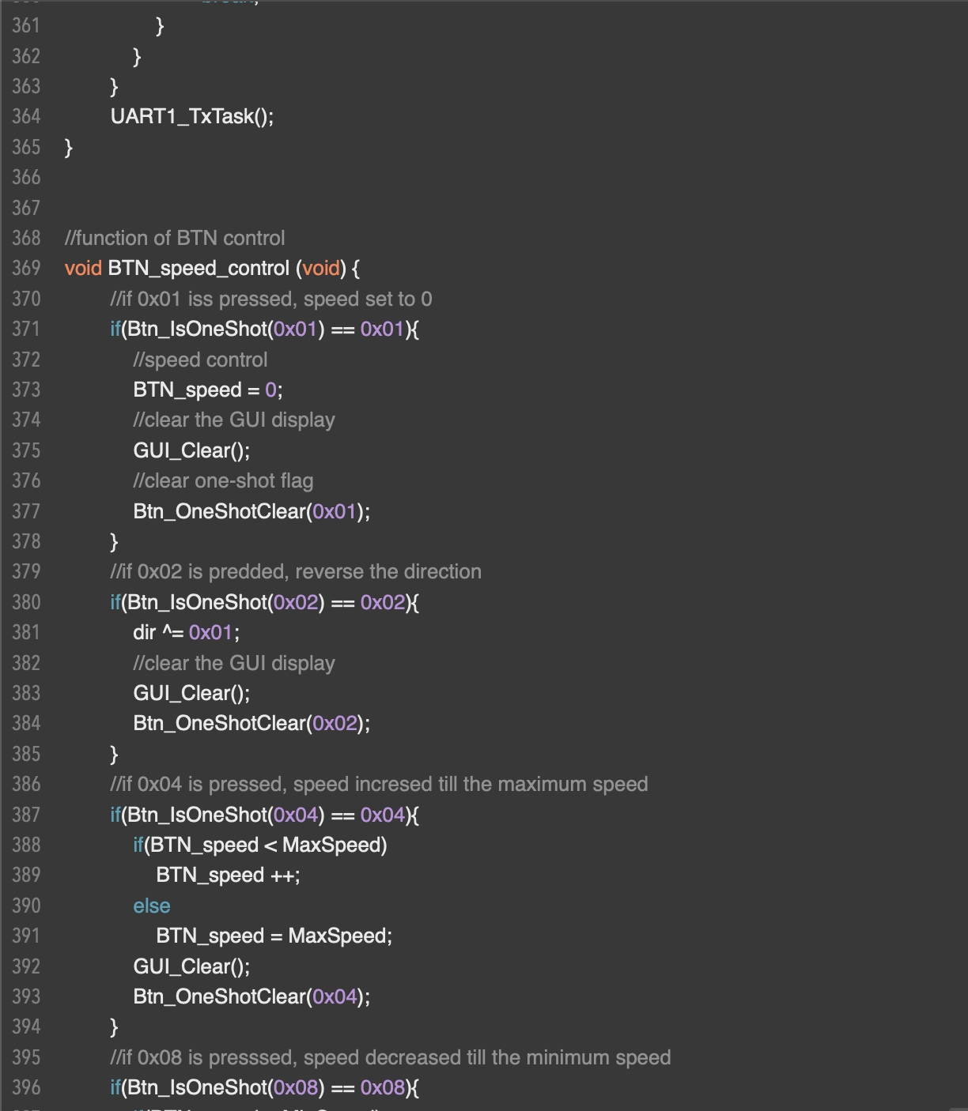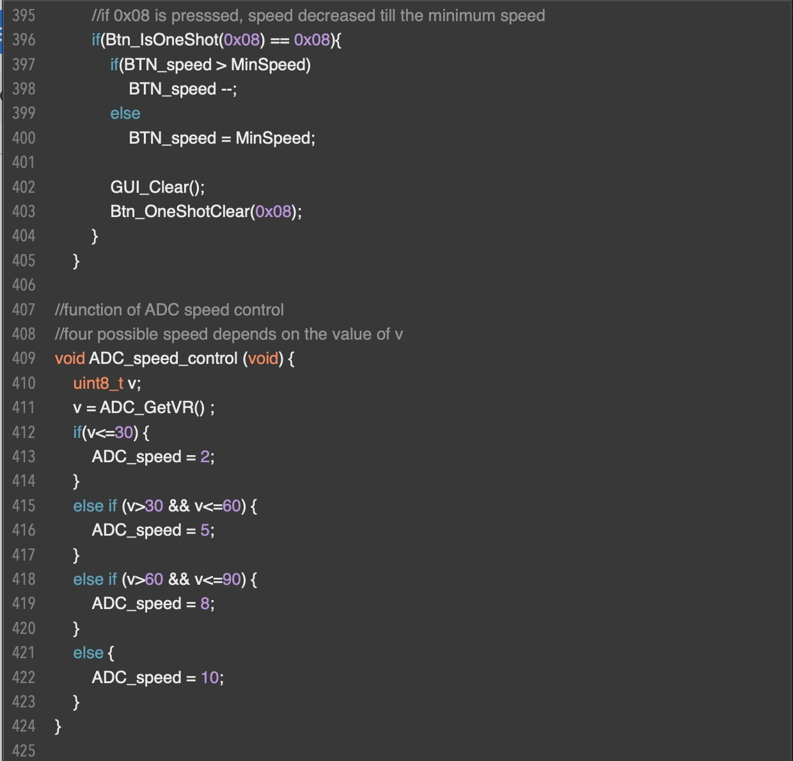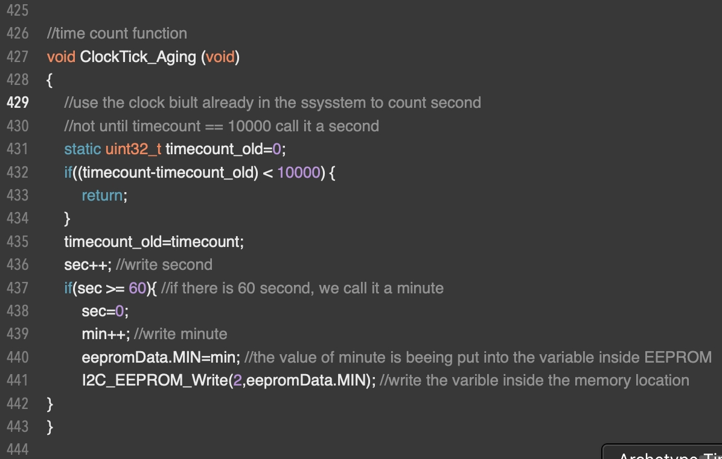

1. Program Flow

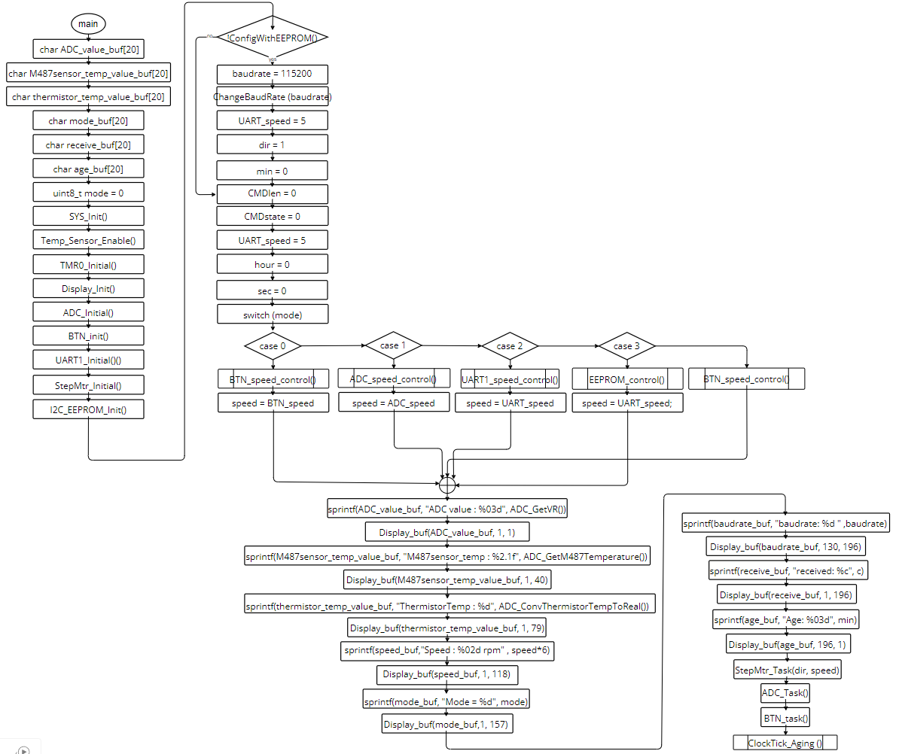

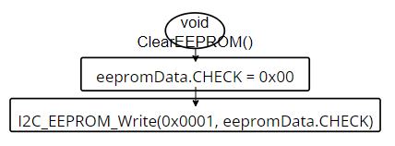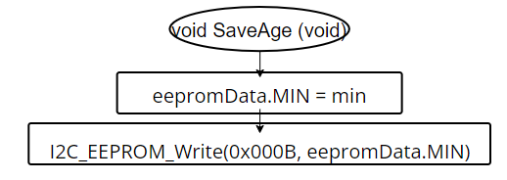

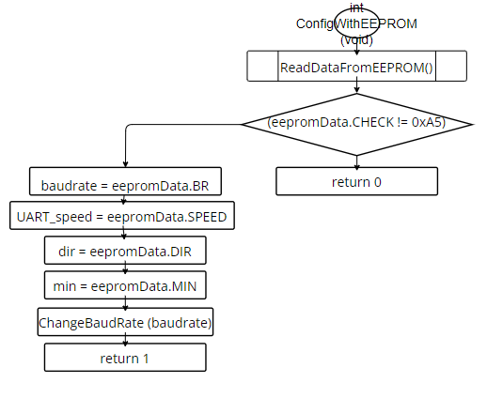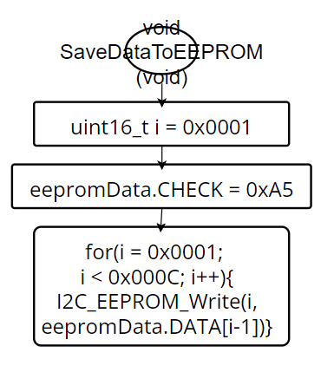

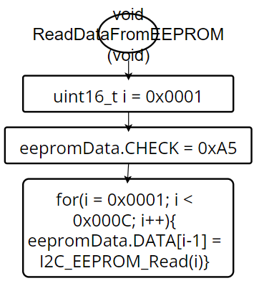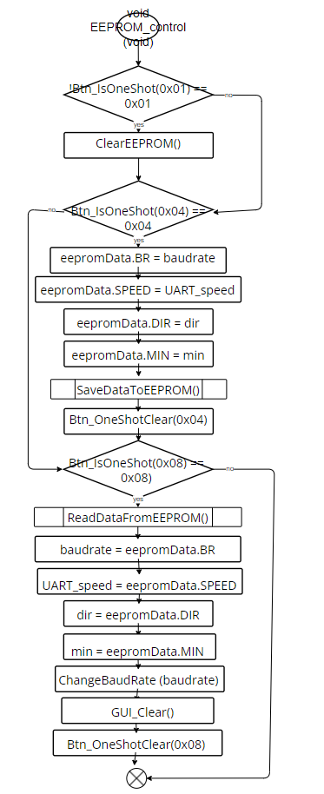

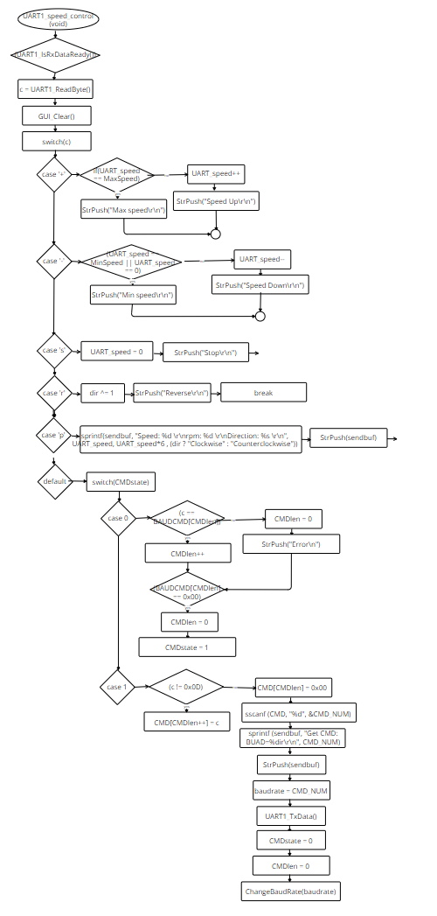

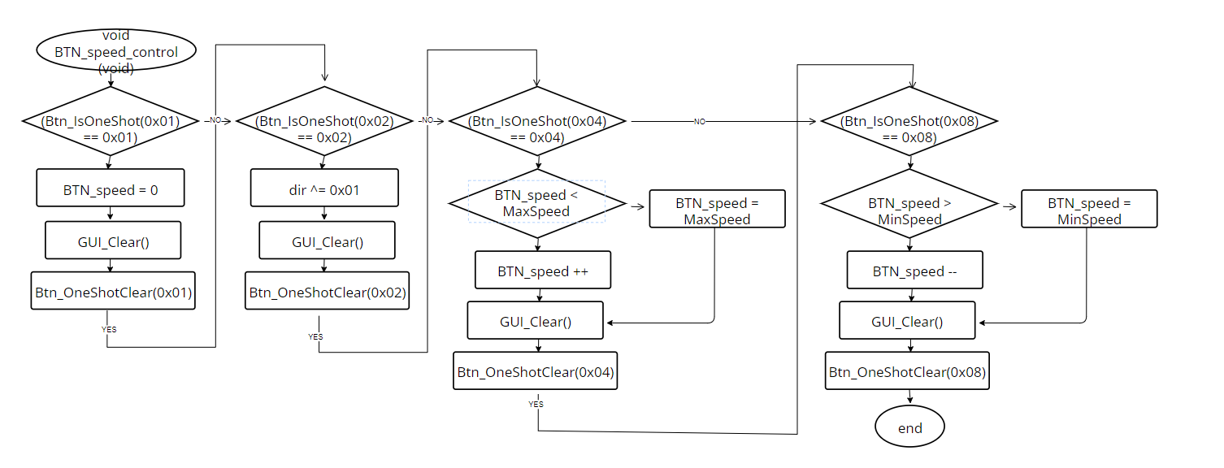

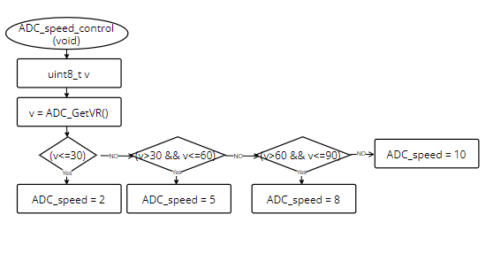

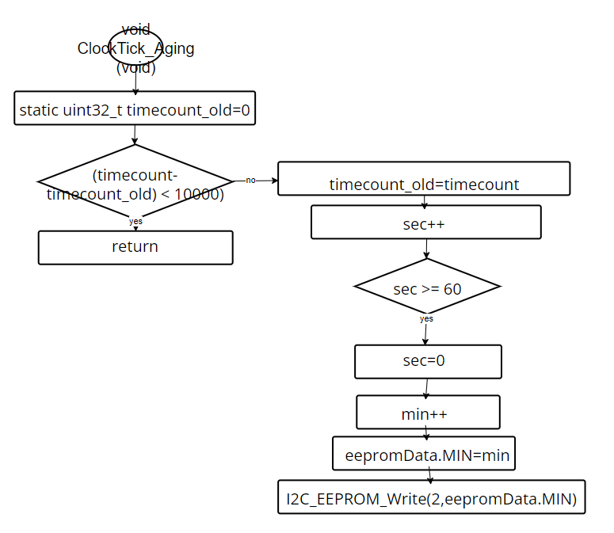

1. Thoughts

This electrical engineering experiment has provided a rich learning experience and valuable insights. We employed C language, stepper motors, UART communication interface, RealTerm software, and EEPROM to construct a versatile stepper motor system capable of mode switching. Building upon our previous experiments, where we became adept at using C language to control stepper motors and display relevant information on the board, this experiment introduced a new element: EEPROM.

Unlike previous iterations, this time we integrated EEPROM into the system to access time data. This crucial addition ensures that even in the event of power loss, the system's configurations and information remain intact within the EEPROM, thereby guaranteeing system stability and reliability.

Throughout this experiment, I gained significant knowledge and skills:

I familiarized myself with the operation principles of the I2C communication interface and learned how to utilize it for data transmission in practical applications.

I mastered the operations of EEPROM, including reading and writing data, and grasped its importance in embedded programming for preserving system configurations.

I learned how to utilize EEPROM effectively in embedded programming to store system configurations, thereby enhancing system reliability and stability.

Through this experiment, our stepper motor system has become more refined, flexible, and reliable. It represents a significant exploration in the field of electrical engineering and lays a solid foundation for our future learning and research endeavors.